INVITATION FOR BID | 18B-2154 | BID ISSUE DATE | 8/16/18
BID DESCRIPTION | SNOW PLOWING SERVICES
BID OPENING DATE | 9/7/18 | BID OPENING TIME | 11:00 AM
SUBMIT ONE (1) ORIGINAL, PLUS ONE (1) COPY |  | BOND REQUIRED | NONE

TO ALL PROSPECTIVE BIDDERS:
You are hereby invited to submit your bid for the service Snow Plowing to be provided to the addresses specified herein. The original bid, and the required number of copies, must be received in a sealed envelope that has your name and address in the UPPER left corner and the attached Return label filled in and attached on the LOWER left corner.
All bids are subject to staff analysis. The County of Winnebago reserves the right to accept or reject any and all bids received and waive any and all technicalities. Bids must be delivered to:
WINNEBAGO COUNTY PURCHASING DEPARTMENT 404 ELM STREET, ROOM 202, ROCKFORD, IL 61101
BID RESPONSES MUST BE RECEIVED AND TIME STAMPED NO LATER THAN THE PUBLIC BID OPENING DATE AND TIME SPECIFIED ABOVE. BIDS WILL BE OPENED AND READ ALOUD AT THAT TIME IN THE PROCUREMENT SERVICES DIVISION. LATE BIDS WILL NOT BE CONSIDERED.
Any communication regarding this invitation between the date of issue and date of award is required to go through the Director of Purchasing. FACSIMILE AND/OR E-MAIL TRANSMITTED BIDS WILL NOT BE ACCEPTED.

Sincerely,

Ann Johns
Director of Purchasing

BIDDER
CONTACT PERSON
TELEPHONE
EMAIL
CALL FOR BIDS

PROJECT NAME | SNOW PLOWING SERVICES
USER DEPARTMENT | FACILITIES
EVENT | LOCATION | DATE | TIME (CST)
LEGAL ADVERTISEMENT | ROCKFORD REGISTER STAR  WEBSITE: HTTP://WINCOIL.US/ | 8/16/18 | -----------------
NON-MANDATORY PRE-BID CONFERENCE | NONE | -------------- | ----------------
DEADLINE FOR INQUIRIES, EXCEPTIONS AND QUESTIONS | MUST BE SUBMITTED IN WRITING TO: AJOHNS@WINCOIL.US | 8/23/18 | 10:00 AM
RESPONSE TO QUESTIONS OR INQUIRIES AND ISSUE OF ANY ADDENDUM | VIA E-MAIL | 8/27/18 | 2:00 PM
BID DUE AND PUBLIC OPENING | PURCHASING DEPARTMENT  ROOM 202 | 9/7/18 | 11:00 AM

ALL BIDS MUST BE ENCLOSED IN SEALED ENVELOPES MARKED:

“SNOW PLOWING SERVICES”
Information is available from the Purchasing Department, Winnebago County Administration Building, 404 Elm Street, Room 202, Rockford, Illinois 61101. Telephone: (815) 319-4380, Email: Purchasing@WinCoIL.us
The documents constituting component parts of the Bid Form are the following:
I CALL FOR BIDS
II REQUIREMENTS FOR BIDDING AND INSTRUCTIONS TO BIDDERS
III GENERAL CONDITIONS
IV SPECIAL CONDITIONS
V BID SPECIFICATIONS/SCOPE OF WORK
VI BID FORM
VII BUSINESS REFERENCES
VIII BIDDER’S SUBCONTRACTORS
IX RETURN BID LABEL

REQUIREMENTS FOR BIDDING AND INSTRUCTIONS TO BIDDERS

SUBMISSION OF BIDS
The Bidder, by its officers, agents or representatives (hereafter referred to as the Bidder), shall be responsible for delivery of bids to the Purchasing Department before the date and hour set for the opening of bids. Late bids will not be considered and will be returned unopened.
All bids must be received in a sealed envelope that has your name and address in the UPPER left corner and the attached Return label filled in and attached on the LOWER left corner.
Bids mailed "EXPRESS MAIL" must have bid number and due date on the outside of the EXPRESS MAIL envelope. You must allow sufficient time for processing through the County’s internal mailroom system.
PREPARATION OF BID
The Bidder must submit a bid on the forms furnished by the Winnebago County Purchasing Department. All blank spaces on the bid form must be filled in. Use "N/A" or "None" where applicable.
Where unit prices are to be bid, and/or where bids are to be made on more than one item, the Bidder shall extend the unit price(s) bid in the places provided on the pricing pages for the approximate quantities, shall compute the total amount of the bid and shall indicate same on the bid pricing page. The Bidder must bid in accordance with the unit(s) of measure called for unless deviation procedure is followed. All extensions and total sums are subject to verification by the County and the correct extensions and sums will be used in the comparison of bids. If a discrepancy exists between the unit prices and totals, the unit prices shall prevail. If a discrepancy exists between the total base bid and the true sum of the individual bid items, the true sum shall prevail.
Where unit prices are requested, the quantities stated are approximate only but will be used to determine bid award. The quantities for all items on which bids are to be received on a unit price basis, will not be used in establishing final payment due the Contractor. Bids will be compared based on number of units stated in the Bid Pricing Section. Contract payment for unit price items will be based on the actual number of units delivered.
Authorized signature must be the individual owner of a proprietorship, a general partner of a partnership, or signed in the name of a corporation by an officer whose title shall be stated. Bids shall be sealed in an envelope and marked as required in the instructions. The bid is contained in these documents and must remain attached hereto when submitted.
ENTIRE AGREEMENT
These Standard Terms and Conditions of the Bid shall apply to any contract or order awarded as a result of this Bid except where special requirements are stated elsewhere in the Bid; in such cases the special requirements shall apply. Further, the written contract and/or order with referenced parts and attachments shall constitute the entire agreement and no other terms and conditions in any document, acceptance, or acknowledgement shall be effective or binding unless expressly agreed to in writing by the contracting authority.
DEVIATIONS, EXCEPTIONS OR ALTERNATES
Deviations, exceptions or alternates from terms, conditions, or specifications shall be described fully, on Bidder’s letterhead, signed, and attached to the Invitation for Bid. In the absence of such statement, the bid shall be accepted as in strict compliance with all terms, conditions, and specifications and the Bidder shall be held liable. Bidders are cautioned to avoid making deviations and exceptions to the specifications, which may result in rejection of their bid. If deviations, exceptions or alternates are submitted, it is the Winnebago County Director of Purchasing’s sole and final decision whether specifications have been met and will be considered for award.
ELECTRONIC TRANSMITTALS
Facsimile and/or e-mail transmitted bids will not be accepted by the County of Winnebago. In addition, the County of Winnebago will not transmit facsimile specifications to the Bidder.

END OF REQUIREMENTS FOR BIDDING AND INSTRUCTIONS TO BIDDERS

GENERAL CONDITIONS
ADDENDUM AND SUPPLEMENT TO THE BID
If it becomes necessary or advisable to revise any part of this Bid or if additional data is necessary to enable the exact interpretation of provisions of this Bid, revisions will be provided in the form of an Addendum. If revisions are made after any mandatory Pre-Bid conference, the revisions will be provided only to those Contractors who will have attended the Pre-Bid conference.
In the event that any addenda to this Bid are issued, a public posting a minimum of 7 days will be adhered to, and could result in a revised date for the opening of this bid.
Addendum information is available at the County’s website http://WinCoIL.us/ We strongly suggest that you check for any addenda a minimum forty-eight hours (48) in advance of the bid deadline.
APPLICABLE CODES AND ORDINANCES
Bidder hereby certifies that all services and/or materials used or performed conform to all articles and sections of all current applicable National Building Codes, OSHA, IDOT, Federal, State and other relevant codes. Workmanship and materials shall conform to all local applicable codes and ordinances.
CANCELLATION
The County of Winnebago reserves the right to cancel any contract in whole or in part without penalty due to failure of the contractor to comply with terms, conditions and specifications of this contract.
Certification regarding debarment, suspension, ineligibility and voluntary exclusion
The Bidder certifies, by submission of this bid or acceptance of this contract, that neither it nor its principals is presently debarred, suspended, proposed for debarment, declared ineligible, or voluntarily excluded from participation in this transaction by any Federal department or agency. It further agrees by submitting this bid that it will include this clause without modification in all lower tier transactions, solicitations, bids, contracts, and subcontracts. Where the Bidder/Contractor or any lower tier participant is unable to certify to this statement, it shall attach an explanation to this solicitation.
Additionally, for all new contractors and vendors to be paid, the Purchasing Department will review the Federal and State Excluded Parties List System prior to requesting the vendor be created in our accounting system.
CHANGES
The County of Winnebago reserves the right to make any desired change in the specifications after the same shall have been put under contract; but the change so made, with the price to be added or deducted from the contract price, therefore, shall be agreed upon in advance between County and the successful Bidder.
The Purchasing Department shall issue to the successful Bidder a written change order to the original contract; such change orders shall be binding upon both parties thereto and shall in no way invalidate or make void the terms of the original contract not modified by such change.
COMMENCEMENT OF WORK
The successful Contractor must not commence any billable work prior to the County's execution of the contract, issuance of a purchase order or until all required documents have been submitted. Work done prior to these circumstances shall be at the Contractor's risk.

COMPLIANCE WITH LAWS
All services, work and materials that in any manner affect the production, sale, or payment for the product or service contained herein must comply with all Federal, State, County and Municipal laws, statutes, regulations, codes, ordinances and executive orders in effect now or later and whether or not they appear in this document, including those specifically referenced herein. The successful Bidder must be authorized to do business in the State of Illinois, and must be able to produce a Certificate of Good Standing with the State of Illinois upon request.
Bidder/Contractor must obtain all licenses, certificates and other authorizations required in connection with the performance of its obligations hereunder, and Bidder/Contractor must require any and all subcontractors to do so. Failure to do so is an event of disqualification and/or default and may result in the denial of this bid and/or termination of this Agreement.
In the event Federal or State funds are being used to fund this contract; additional certifications, attached as addenda, will be required. Lack of knowledge on the part of the vendor will in no way be cause for release of this obligation. If the County becomes aware of violation of any laws on the part of the vendor, it reserves the right to reject any bid, cancel any contract and pursue any other legal remedies deemed necessary.

COST OF BID
Expenses incurred in the preparation of bids in response to this bid is the Bidder's sole responsibility.

DISPUTES
In case of disputes as to whether or not an item or service quoted or delivered meets specifications, the decision of the Director of Purchasing, or authorized representative shall be final and binding to all parties.

FREEDOM OF INFORMATION
Any responses and supporting documents submitted in response to a bid will be subject to disclosure under the Illinois Freedom of Information Act. The County will assume that all information provided in a bid is open to inspection or copying by the public unless clearly marked with the appropriate exception that applies under the Freedom of Information Act. Additionally, if providing documents that you believe fall under an exception to the Freedom of Information Act, please submit both an un-redacted copy along with a redacted copy which has all portions redacted that you deem to fall under a Freedom of Information Act exception.
INDEMNITY
The Bidder shall, at all times, fully indemnify, hold harmless, and defend the County of Winnebago and their officers, agents, and employees from and against any and all claims and demands, actions, causes of action, and cost and fees of any character whatsoever made by anyone whomsoever on account of or in any way growing out of the performance of this contract by the Bidder and its employees, or because of any act or omission, neglect or misconduct of the Bidder, its employees and agents or its subcontractors including, but not limited to, any claims that may be made by the employees themselves for injuries to their person or property or otherwise, and any claims that may be made by the employees themselves or by the Illinois Department of Labor for the Bidder’s violation of the Illinois Prevailing Wage Act (820 ILCS 130/1 et seq.). Such indemnity shall not be limited by reason of the enumeration of any insurance coverage or bond herein provided. Nothing contained herein shall be construed as prohibiting the County of Winnebago and their officers, agents, or its employees, from defending through the selection and use of their own agents, attorneys and experts, any claims, actions or suits brought against them. The Bidder shall likewise be liable for the cost, fees and expenses incurred in the County of Winnebago’s or the Bidder’s defense of any such claims, actions, or suits. The Bidder shall be responsible for any damages incurred as a result of its errors, omissions or negligent acts and for any losses or costs to repair or remedy construction as a result of its errors, omissions or negligent acts.
NON-BARRED BIDDING

The Bidder certifies, by submission of this bid, that it is not barred from bidding on this contract as a result of a conviction for the violation of state laws prohibiting bid rigging or bid rotating.
NON-COLLUSION
The Bidder, by its officers, agents or representatives present at the time of filing this bid, say that neither they nor any of them, have in any way directly or indirectly, entered into any arrangement or agreement with any other Bidders, or with any public officer of the County of Winnebago, Illinois, whereby, the Bidder has not paid or is to pay to such Bidder or public officer any sum of money, anything of value or has not directly or indirectly entered into any arrangement or agreement with any other Bidder or Bidders. Whereby, no inducement of any form or character other than that which appears upon the face of the bid will be suggested, offered, paid or delivered to any person whomsoever to influence the acceptance of the said bid or understanding of any kind whatsoever, with any person whomsoever to pay, deliver to, or share with any other person in any way or manner, any of the proceeds on the Contract sought by this bid.
NON-DISCRIMINATION
In connection with the performance of work under this contract, the Contractor agrees not to discriminate against any employee or applicant for employment because of age, race, religion, color, handicap, sex, physical condition, developmental disability, sexual orientation or national origin. This provision shall include, but not be limited to, the following: employment, upgrading, demotion or transfer, recruitment or recruitment of compensation, and selection for training, including apprenticeship. Except with respect to sexual orientation, the Contractor further agrees to take affirmative action to ensure Equal Employment Opportunities. The Contractor agrees to post in conspicuous places, available for employees and applicants for employment, notices to be provided by the contracting officer setting forth the provisions of the Non-Discrimination Clause.
PROMPT PAYMENT ACT
All County payments are subject to the Local Governmental Prompt Payment Act.
PROTEST
Firms wishing to protest bids or awards shall notify the Director of Purchasing in writing within 5 days after the invitation to bid opening. The notification should include the bid number, the name of the firm protesting and the reason why the firm is protesting the bid. The Director of Purchasing will respond to the protest within 5 calendar days.
RESERVATION OF RIGHTS
The County of Winnebago reserves the right to reject any or all bids failing to meet the County's specifications or requirements and to waive technicalities. If in the County of Winnebago's opinion, the lowest bid is not the most responsible bid, considering value received for monies expended, the right is reserved to make awards as determined solely by the judgment of the County of Winnebago. In determining the lowest responsible Bidder, the County shall take into consideration the qualities of the articles supplied, their conformity with the specifications, and their suitability to the requirements of the County and the delivery terms. Intangible factors, such as the Bidder’s reputation and past performance, will also be weighed.
The County of Winnebago reserves the right to award to more than one vendor, as it deems in the best interest to do so.
The Bidder’s failure to meet the mandatory requirements of the Bid will result in the disqualification of the bid from further consideration.
The County further reserves the right to reject all bids and obtain goods or services through intergovernmental or cooperative agreements, or to issue a new and revised Bid.
Submission of a bid confers no rights on the Contractor to a selection or to a subsequent contract. All decisions on compliance, evaluation, terms and conditions shall be made solely at the County's discretion and shall be made in the best interest of the County.
SUBCONTRACTORS
If applicable all subcontractors shall be identified on the form contained herein. Contractor shall require that the subcontractor comply with all Prevailing Wage Act requirements. The County of Winnebago reserves the right to reject any or all subcontractors.
Substance Abuse Prevention
The Substance Abuse Prevention on Public Works Act, Public Act 95-0635, prohibits the use of drugs and alcohol, as defined in the Act, by employees of the contractor and by employees of all approved subcontractors while performing work on a public works project. The contractor/subcontractor hereby certifies that it has a superseding collective bargaining agreement or makes the public filing of its written substance abuse prevention program for the prevention of substance abuse among its employees who are not covered by a collective bargaining agreement dealing with the subject as mandated by the Act.
Bidders and their subcontractors (if applicable) certifies that the entity has signed collective bargaining agreements that are in effect for all of its employees, and that deal with the subject matter of Public Act 95-0635, or certifies that the contracting entity has in place for all of its employees not covered by a collective bargaining agreement a written substance abuse prevention program that deals with subject of the Act, and will attach the substance abuse prevention program that meets or exceeds the requirements of Public Act 95-0635.
TAXES NOT APPLICABLE
The County of Winnebago as a Governmental Unit pays neither Federal Excise Tax nor Illinois Retailers Occupational Tax, and therefore, those taxes should be excluded from bid. Our Tax Exempt Number is: E9992-3963-07.
TERMINATION, CANCELLATION AND DAMAGES
The County may terminate based on the Contractor’s breach or default. Unless the breach or default creates an emergency, as determined in the County’s sole discretion, the Contractor shall be given notice and a five (5) day opportunity to cure before the termination becomes effective.
If the County terminates this Contract because of the Contractor’s breach or default, the County shall have the right to purchase items or services elsewhere and to charge the Contractor with any additional cost incurred, including but not limited to the cost of cover, incidental and consequential damages and the cost of re-bidding. The County may offset these additional costs against any sums otherwise due to the Contractor under this bid or any unrelated contract.
If the County of Winnebago fails to appropriate funds to enable continued payment of multi-year contracts the County may cancel, without termination charges provided Contractor received at least thirty (30) days prior written notice of termination.
The County of Winnebago may terminate any contract or agreement resulting from this Bid or RFP at any time for any reason by giving at least thirty (30) days’ notice in writing to awarded Contractor. If the contract is terminated by the County as provided herein, the contractor will be paid a fair payment as negotiated with the County for the work completed as of the date of termination.
WITHDRAWAL OF BIDS
Any Bidder may withdraw their bid at any time prior to the time specified in the advertisement as the closing time for the receipt of bids by signing a request therefore. However, no Bidder shall withdraw or cancel his bid for a period of sixty (60) days after said advertised closing time for the receipt of bids; the successful Bidder shall not withdraw or cancel their bid after having been notified by the Director of Purchasing that said bid has been accepted by the County Board.

The Bidder, by signing the bid form, acknowledges, understands and abides by all of the above "Requirements for Bidding and Instructions to Bidders".

END OF GENERAL CONDITIONS

SPECIAL CONDITIONS
QUESTIONS & INQUIRES
Any questions and/or inquires may be directed, no later than the date provided for on page 2 to Ann Johns, Director of Purchasing, 404 Elm Street, Room 202, Rockford, Illinois 61101, by Telephone: (815) 319-4380 or Email: purchasing@wincoil.us
BONDING
Not required for this project.
RENEWALS AND EXTENSIONS
The contract may be subject to four (4) additional one (1) year renewal periods provided there is no change in the terms, conditions, specifications, and prices and provided that such renewals are mutually agreed to by both parties, based in part on satisfactory completion of the initial contract. In no event shall the term, plus renewals, exceed five (5) years.
PRICE ESCALATION
If the parties elect to renew the contract, compensation to the Contractor for succeeding years will be based on the appropriate prior year average of the Consumer Price Index published by U.S. Department of Labor, not seasonally adjusted. The request for a contract price escalation must be done by the contractor, in writing, no less than ninety (90) days prior to the contract (annual) end date.

BID AWARD CRITERIA
This bid will be awarded to the lowest responsive, responsible Bidder meeting specifications.
PERMITS, FEES, AND NOTICES
The Awarded Contractor shall secure and pay for all Building Permits and Governmental Fees, licenses, and inspections necessary for the proper execution and completion of the work, which are legally required, file all notices, comply with all laws, rules, regulations and lawful orders bearing on the performance of the work.
INSURANCE REQUIREMENTS
Upon notice of acceptance of bid, the successful Bidder shall, within fourteen (14) calendar days of said notice, furnish to the Director of Purchasing a Certificate of Insurance and provide policy endorsements evidencing specific coverage of the types of insurance in the amounts specified below. Such coverage shall be placed with a responsible company acceptable to the County licensed to do business in the State of Illinois. All required insurance shall be maintained by the contractor in full force and effect during the life of the contract, and until such time as all work has been approved and accepted by the County. The Contractor is responsible for all insurance deductibles and Self-Insured Retentions.

 | TYPE OF INSURANCE | MINIMUM ACCEPTABLE LIMITS OF LIABILITY
1 | Workers Compensation | Statutory
2 | Employers Liability
 | A. Each Accident | $1,000,000
 | B. Each Employee-disease | $1,000,000
 | C. Policy Aggregate-disease | $1,000,000
3 | Commercial General Liability
 | A. Per Occurrence | $2,000,000
 | B. General Aggregate
 | 1. General Aggregate- Per project | $2,000,000
 | 2. General Aggregate - Products/ Completed Operations | $2,000,000
4 | Business Auto Liability | $1,000,000

At all times during the term of the contract, the Contractor and its independent contractors shall maintain, at their sole expense, insurance coverage for the Contractor, its employees, officers and independent contractors, as follows:
- It is the responsibility of Contractor to provide copy of the BID to their carrier.
- It may also be required that the Contractor's insurer and coverage be approved by County prior to execution of the Contract.
- No work shall be started until receipt of Certificate of Insurance.
The County of Winnebago shall be named as additionally insured on all certificates of insurance. Insurance certificates shall also reference project name and BID NUMBER. Certificates should be sent to:

Winnebago County
Purchasing Department
404 Elm Street, Room 202
Rockford, IL 61101
purchasing@wincoil.us

The insurance carrier of the insured is required to notify the County of Winnebago of termination of any or all of these coverages, prior to the completion of any contract, at least thirty (30) days prior to expiration.
CHANGES IN INSURANCE COVERAGE:
The Contractor will immediately notify the county if any insurance has been cancelled, materially changed, or renewal has been refused and the Contractor shall immediately suspend all work in progress and take the necessary steps to purchase, maintain and provide the required insurance coverage(s) and limits. If suspension of work should occur due to insurance requirements, upon verification by the County of the required insurance the County will notify Contractor when they can proceed with the work. Failure to provide and maintain the required insurance coverage(s) and limits could result in immediate cancellation of the contract and the Contractor shall accept and bear all costs that may result due to the Contractors failure to provide and maintain the required insurance.
END OF SPECIAL CONDITIONS
BID SPECIFICATIONS/SCOPE OF WORK

All work shall be performed in compliance with Occupational Safety and Health Administration (OSHA) Standards and Regulations. The County of Winnebago is seeking bids for Plowing Snow from County parking lots after a snowfall event of 2″ or greater, and piling snow in a designated collection area or hauling offsite. Since the workload is entirely dependent upon the forces of nature, the successful Bidder’s workload is not predictable.

CONTRACTOR QUALIFICATIONS

No contract shall be awarded except to responsible Bidders capable of performing the class of work contemplated.

Before being considered for the award of contract, Bidder may be required to show evidence of necessary experience, facilities, equipment, ability, and financial resources to perform the work in a satisfactory manner and within the time stipulated.

Bidders must supply up to three references that can attest to the contractor’s performance of the same general type of work as described by this invitation to bid. The County reserves the right to contact each of the references provided to assess the Bidder’s ability to perform the work described by this invitation to bid.

INSURANCE

The successful Bidder, upon award, shall be required to provide a certificate of insurance effective for the duration of the contract showing Comprehensive General Liability Insurance, Comprehensive Commercial Vehicle Liability Insurance coverage, Worker’s Compensations, and Property Insurance Coverage.

Upon notification of award, the contractor shall provide the County as an additional insured to the above-referenced policies and provide the County with a certificate of insurance that lists the County of Winnebago as an additional insured. The County shall be notified in writing of any reduction, cancellation, or substantial change of policy or policies at least thirty (30) days prior to the effective date of said action.

DAMAGE TO COUNTY OWNED STRUCTURES

The contractor shall be responsible for any and all damage caused in whole or in part by the contractor to the lots, structures and adjacent private property covered under this contract.

BASIS OF AWARD

The contract will be awarded to the lowest responsible and responsive Bidder based on the prices bid for each service category.

FAILURE TO PERFORM

In the event the contractor fails to clear the snow from the parking lots assigned in the timeframe specified, the County reserves the option to retain the services of another contractor of its choice to complete the work. In the event that the contractor twice fails to clear the snow from any or all parking lots assigned in the timeframe specified, the County reserves the right to cancel the contract and reassign the work to another contractor for the remainder of the season. The contractor will also be declared non-responsible and prohibited from bidding on contracts with the County for a period of five (5) years.

CONTRACT PERIOD

The contract will be for one (1) year with four (4) one (1) year options.

SITE VISITS

Bidders can view sites at any time.

METHOD OF BIDDING

Maps showing general layouts of lots, as well as locations, are included in Table 1 of this document. The County will require a bid price for both Winnebago County Health Department locations, the Carrie Lynn Center, the parking lot located on the corner of Church and Chestnut that we will refer to as the “Hawk’s Nest Lot”, the Winnebago County Juvenile Justice Center, and the Winnebago County Justice Center. The bid price for snow removal at these locations must be a complete price, including sidewalks, per completed snow removal service*. Snow hauling prices will be bid at an hourly rate for any piece of equipment used to remove snow, and a labor-per-hour rate, on an as-needed basis, as determined by the County’s agent.

The County handles plowing at some of our other locations, but due to the lack of space to pile snow, we are sometimes forced to place piles in various locations next to our lots that need to be hauled offsite. The County is asking for an hourly rate plus a rate for equipment to perform this service. This will be requested by the County as needed. We will have it hauled to a location along Chestnut Street South of the Justice Center. Rates should include labor and equipment.

Any questions may be directed to Ann Johns, Director of Purchasing, 404 Elm Street, Room 202, Rockford, Illinois 61101, by telephone 815-319-4380 or email purchasing@wincoil.us

*A completed snow removal service will be defined as one completed incidence of snow removal per defined area, servicing that entire area. Depending upon the rates of snowfall, it is conceivable that snow removal services may need to be performed in multiples.

NOTIFICATION OF CONTRACTOR

When snow is falling, it will be the contractor’s responsibility to automatically respond. The County of Winnebago will require a contact person name and number available 24 hours in the event any issues arise.

TIMING OF WORK

Each lot has various times for plowing and snow levels. Times will be stated specifically in “Table 1”. Since parking is permitted in all County lots on a 24-hour basis, the County does not guarantee that the lots will be empty of all parked vehicles during a scheduled plowing time and assumes no responsibility for removing any parked vehicles.

STANDARD EQUIPMENT ON PLOWING EQUIPMENT

Rubber tired or rubber-tracked vehicles shall be used in plowing operations. All plow vehicles are to be equipped with standard headlights, taillights and rotating amber warning lights.

PLACEMENT OF PLOWED SNOW

The snow shall be deposited in designated collection areas and pushed or piled to occupy a minimum number of parking stalls at those locations. The County will identify designated collection areas.

The removal and/or hauling of piled snow from certain parking lots should be included in this contract.

SPECIAL CONDITIONS

All areas will require at least one (1) salt/sand application. Salt will be provided by the County for parking lots. The County has a salt storage area located at CJC loading dock area. The Bidder will need to contact the County when they are getting low so, we can schedule deliveries. This salt must only be used for the County of Winnebago purposes. The contractor will provide potassium chloride for the sidewalks when necessary.

Bidders may bid on any or all lots. Awards will be made by category in whatever combination the County determines to be the most economical and advantageous for the County. Multiple awards may be made.

TABLE 1

Locations, Plow Times and Accumulations

Location | Plow Times | Accumulations
A. Winnebago County Justice Center *
650 W. State Street
1. Sally Ports | Cleared Between  6 P.M. to 6 A.M | 2″ or More
2. Dock Area | Cleared Between  6 P.M. to 6 A.M | 2″ or More
3. Parking Lots | Cleared Between  6 P.M. to 6 A.M | 2″ or More
4. Sidewalks, Front Entrances, Bond-Out | 5:00 P.M. to 6:00 A.M. | 2″ or More
B. Winnebago County Juvenile Justice Center  211 S. Court Street  Parking Lot West of Building | Cleared by  7 A.M.  7 DAYS | 2″ or More
C. Winnebago County Health Department  401 Division Street  Parking Lot | Cleared by  7 A.M.  Mon. – Fri. | 2″ or More
D. Winnebago County Health Department  555 N. Court Street  Parking Lot and Sidewalks  (Redo as necessary during the day not to accumulate over 2″.) | Cleared by  7 A.M.  Mon. – Sat. | 2″ or More
E. Carrie Lynn Center  826 N. Main Street  Parking Lot and Sidewalks | Cleared by  7 A.M.  Mon. – Fri. | 2″ or More
F. Hawk’s Nest Parking Lot (Chestnut & Church)  324 Chestnut  Parking Lot, Sidewalks, and row of spaces that border the south, outside edge of lot. | Cleared by  7 A.M.  7 DAYS | 2″ or More

* Snow will be piled for this location only. All other locations will be temporarily piled but must ultimately be hauled offsite if requested to do so by the County.

At the County’s discretion, and dependent upon the conditions surrounding a snow event, the County retains the right to summon the contractor to perform said snow removal services outside of the plow times listed above.

TABLE 1 (CONTINUED)

LOCATIONS, PLOW TIMES AND ACCUMULATIONS
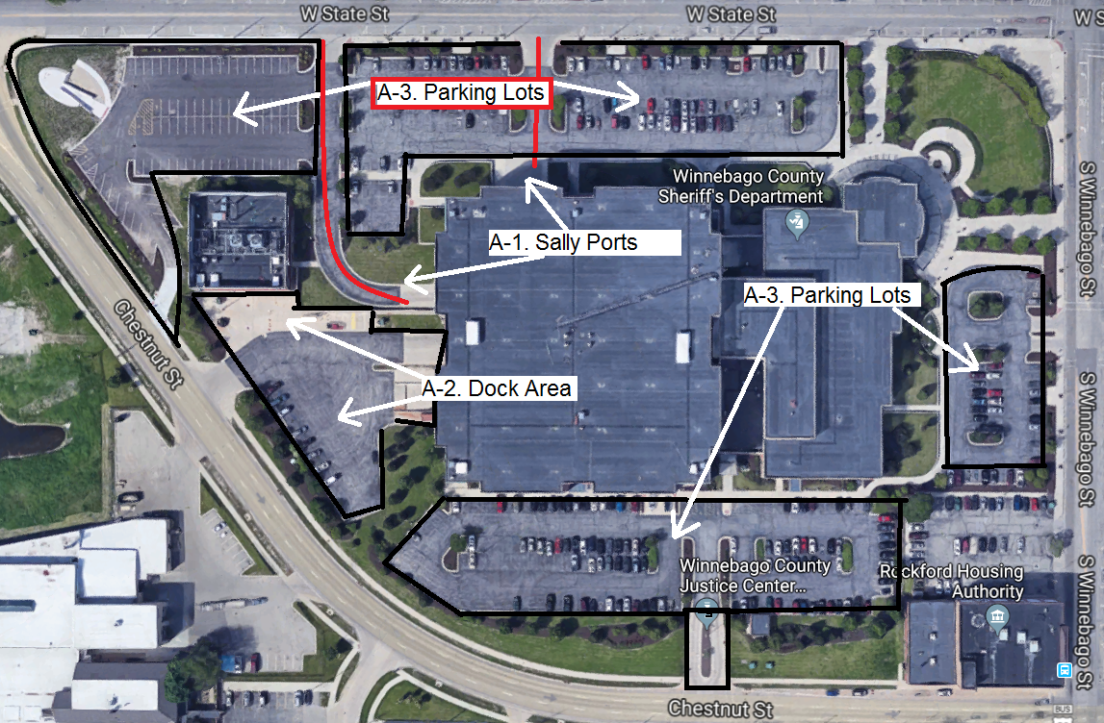
Location A: Sally Ports, Dock Area, and Parking Lots

TABLE 1 (CONTINUED)

LOCATIONS, PLOW TIMES AND ACCUMULATIONS

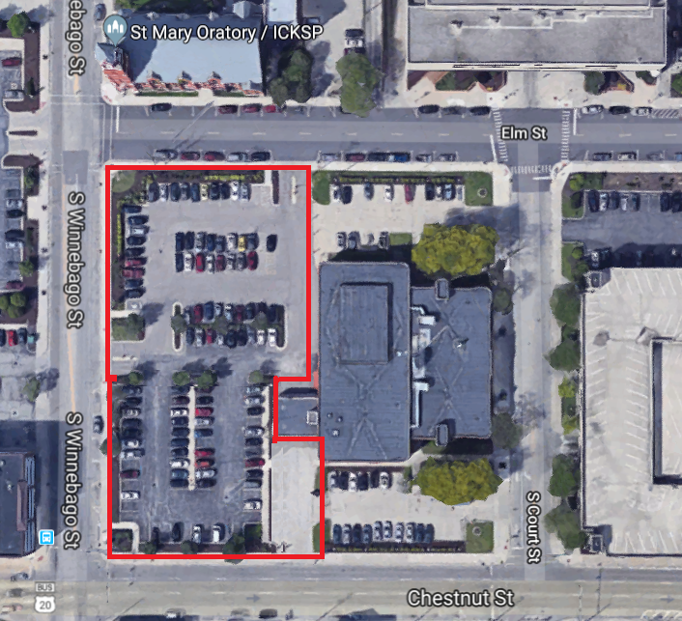

View of the Winnebago County Juvenile Justice Center, 211 Court Street
Location B: Parking Lot West

TABLE 1 (CONTINUED)

LOCATIONS, PLOW TIMES AND ACCUMULATIO
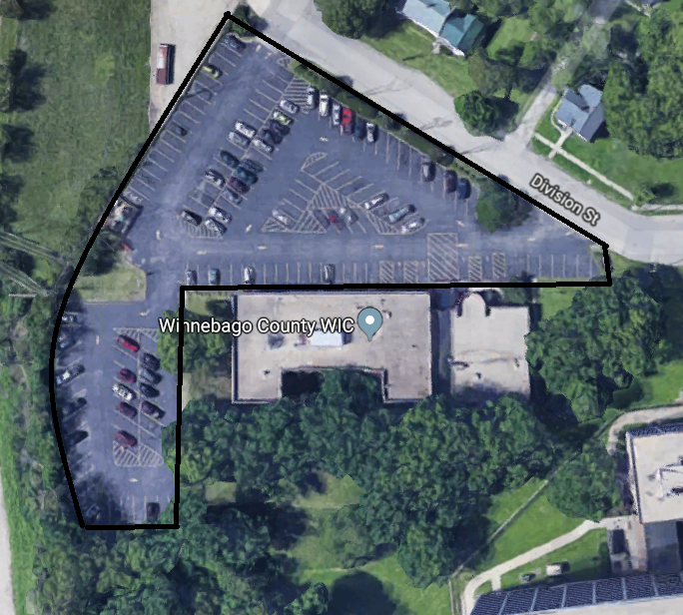
Location C: 401 Division Street

TABLE 1 (CONTINUED)

LOCATIONS, PLOW TIMES AND ACCUMULATIONS
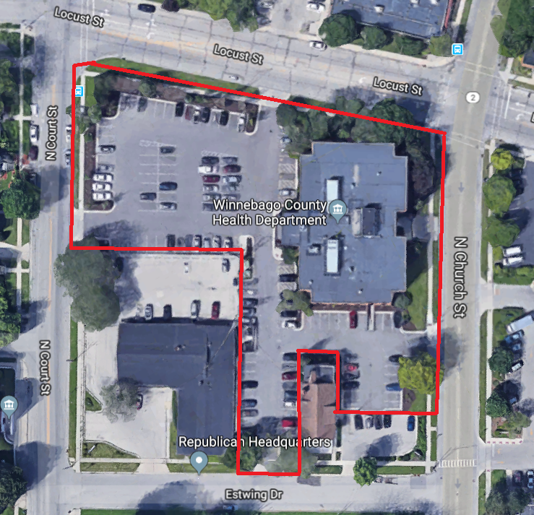

Location C: 555 N Court Street

TABLE 1 (CONTINUED)

LOCATIONS, PLOW TIMES AND ACCUMULATIONS
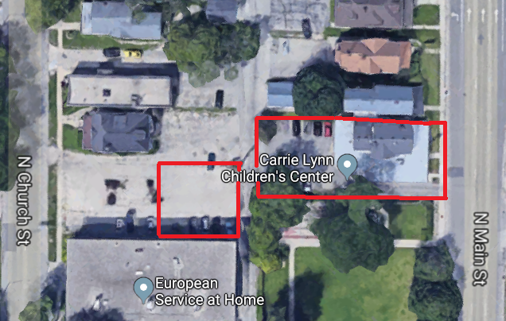

Location E: 826 N. Main Street

TABLE 1 (CONTINUED)

LOCATIONS, PLOW TIMES AND ACCUMULATIONS
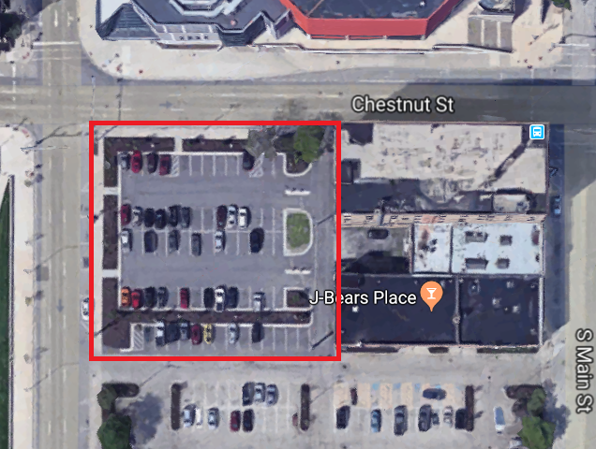

Location F: Hawk’s Nest Lot, 324 Chestnut Street

END OF BID SPECIFICATIONS

BID FORM

BID # 18B-2154
(PLEASE TYPE OR PRINT THE FOLLOWING INFORMATION)
Full Name of Contractor
Contact Person
Business Address
City, State, Zip Code
Telephone |  |  |  |  | FEIN No.
Email
Company Information
Woman Business Enterprise (WBE) |  | Yes |  | No
Small Business Enterprise (SBE) |  | Yes |  | No
Minority Business Enterprise (MBE) |  | Yes |  | No
Veteran Owned Business (VOB) |  | Yes |  | No
IF YES, CHECK THE FOLLOWING BOXES THAT APPLY:
BLACK/AFRICAN AMERICAN |  | HISPANIC
NATIVE AMERICAN OR ALASKA NATIVE |  | ASIAN AMERICAN

TO: Winnebago County Purchasing Department

The undersigned, being duly sworn, certifies that he is:

THE OWNER/SOLE PROPRIETOR | A MEMBER OF THE PARTNERSHIP | AN OFFICER OF THE CORPORATION | MEMBER OF THE JOINT VENTURE

Further, as Contractor, declares that the only person or parties interested in this bid as principals are those named herein; that this bid is made without collusion with any other person, firm or corporation; that he has fully examined the proposed forms of agreement and the contract specifications for the above designated purchase, all of which are on file in the office of the Director of Purchasing, 404 Elm Street, Rockford, Illinois 61101 and all other documents referred to or mentioned in the contract documents, specifications and attached exhibits, including Addenda

No(s): , and issued thereto;

Further, the Contractor proposes and agrees, if this bid is accepted, to provide all necessary machinery, tools, apparatus and other means of construction, including transportation services necessary to furnish all the materials and equipment specified or referred to in the contract documents in the manner and time therein prescribed.
Further, the undersigned certifies and warrants that he/she is duly authorized to execute this certification/affidavit on behalf of the Bidder and in accordance with the Partnership Agreement or By-laws of the Corporation, and the laws of the State of Illinois and that this Certification is binding upon the Bidder and is true and accurate. Further, the undersigned certifies that the Bidder is not barred from bidding on this contract because of a violation of either 720 Illinois Compiled Statutes 5/33 E-3 or 5/33E-4, bid rigging or bid-rotating.
The Affiant deposes and says that he/she has examined and carefully prepared this bid and has checked the same in detail before submitting this bid, and that the statements contained herein are true and correct.
Further, the Bidder certifies that he has provided equipment, supplies or services comparable to the items specified in this contract to the parties listed in the reference section below and authorizes the County to verify references of business and credit at its option. Finally, the Bidder, if awarded the contract, agrees to do all other things required by the contract documents, and that he will take in full payment therefore the sums set forth in the bidding schedule.
Signature of Bidder authorizes the County of Winnebago to verify business references.

BID AWARD CRITERIA:
County Property Location |  | Price Per Completed Snow Removal Service
A. Winnebago County Justice Center – 650 W State St  A1. Sally Port |  | A1: $
A2. Dock |  | A2: $
A3. Parking Lots |  | A3: $
A4. Sidewalks, Front Entrances & Bond-Out |  | A4: $
B. Winnebago County Juvenile Justice Center - 211 S Court  & Parking Lot West of Building – Rockton and Chestnut |  | B: $
C. County Health Department - 401 Division St |  | C : $
D. Winnebago County Health Department - 555 N. Court |  | D: $
E. Carrie Lynn Center - 826 N. Main St |  | E: $
F. Hawk’s Nest Parking Lot - 324 Chestnut St |  | F: $

Snow Hauling Prices:

List Type of Equipment and Capacity |  | List Equipment  Hourly Rate |  | Labor Hourly Rate
 |  | $ |  | $
 |  | $ |  | $
 |  | $ |  | $
 |  | $ |  | $
 |  | $ |  | $
 |  | $ |  | $

SIGNATURE
The undersigned is aware that Prevailing Wage Rates (if applicable) apply to all work performed on this contract. It is the contractor’s responsibility to comply with these requirements and to assure compliance by his/her subcontractors and/or lower tier subcontracts required by this contract.

SIGNATURE
Name and Title of Signer
Dated this |  | day of |  | 20

END OF BID FORM

BUSINESS REFERENCES

The Bidder must list references for the last three (3) completed projects, listing company name, address, contact person, telephone number and date of completion. If Bidder is a new business, provide references that will enable the County to determine if Bidder is responsible.

NAME
CONTACT PERSON
ADDRESS
CITY, STATE, ZIPCODE
TELEPHONE
EMAIL

NAME
CONTACT PERSON
ADDRESS
CITY, STATE, ZIPCODE
TELEPHONE
EMAIL

NAME
CONTACT PERSON
ADDRESS
CITY, STATE, ZIPCODE
TELEPHONE
EMAIL

NUMBER OF YEARS IN BUSINESS
CURRENT NUMBER Of PERSONNEL ON STAFF

END OF BUSINESS REFERENCES

BIDDER’S SUBCONTRACTORS

NAME OF BIDDER
CONTACT PERSON

SUBCONTRACTORS:
Yes |  | No

Will you employ subcontractors?

If "YES", identify with each firm's name, address, telephone number and work to be subcontracted (attach more sheets if necessary).

SUBCONTRACTOR NAME
CONTACT PERSON
ADDRESS
CITY, STATE, ZIPCODE
TELEPHONE
EMAIL
WORK TO BE PROVIDED

The Contractor will not change or use subcontractors not identified in this bid without prior written approval from the County of Winnebago.
A request for a change in subcontractors shall be made in writing and will include a description of any savings that may be realized in the execution of this contract, and must be passed on to the County of Winnebago.

END OF BIDDER’S SUBCONTRACTORS

RETURN BID LABEL


The County of Winnebago, Illinois will receive sealed Bids at:  WINNEBAGO COUNTY  PURCHASING DEPARTMENT  404 ELM STREET, ROOM 202  ROCKFORD, ILLINOIS 61101  All Bids must be enclosed in sealed envelopes marked:  “SNOW PLOWING SERVICES”  9/7/18-11:00 AM | 


ALL SUBMITTALS SHOULD BE LABELED ACCORDINGLY – PLEASE USE BELOW FOR YOUR CONVENIENCE

BID#  18B - 2154 | WINNEBAGO COUNTY PURCHASING DEPARTMENT  404 ELM STREET, ROOM 202  ROCKFORD, ILLINOIS 61101
PURCHASING DIRECTOR:
ANN JOHNS
BID NAME:
SNOW PLOWING SERVICES
BID DUE DATE/TIME:
9/7/18- 11:00 AM

